Example9:
Write a python program to create a GUI window with multiple Labels?
demo.py
from tkinter import *
window=Tk()
window.geometry("800x400")
window.resizable(0,0)
window.title("Vagdevi Technologies")
window.iconbitmap("pytlogo.ico")
window['bg']="red"
L1=Label(window,text="Welcome to Vagdevi Technologies")
L1.place(x=50,y=50)
L2=Label(window,text="Welcome to Vagdevi Technologies",bg="yellow")
L2.place(x=100,y=150)
L3=Label(window,text="Welcome to Vagdevi Technologies",bg="yellow",fg="blue")
L3.place(x=150,y=250)
L4=Label(window,text="Welcome to Vagdevi Technologies",bg="yellow",fg="blue",
font=("arial",15,"italic"))
L4.place(x=200,y=350)
window.mainloop()
output
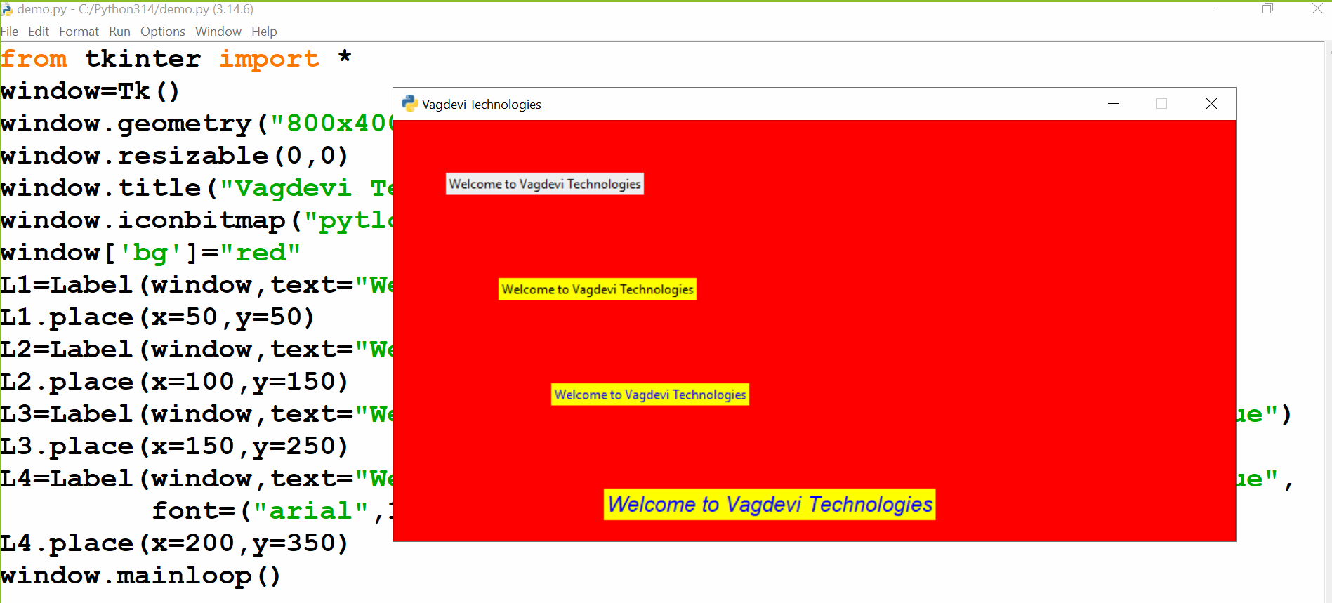
Example10:
Write a python program to create a GUI window with multiple Labels?
demo.py
from tkinter import *
window=Tk()
window.geometry("800x400")
window.resizable(0,0)
window.title("Vagdevi Technologies")
window.iconbitmap("pytlogo.ico")
window['bg']="red"
L1=Label(window,text="Welcome to Vagdevi Technologies")
L1.grid(row=0,column=0)
L2=Label(window,text="Welcome to Vagdevi Technologies",bg="yellow")
L2.grid(row=0,column=1)
L3=Label(window,text="Welcome to Vagdevi Technologies",bg="green",fg="blue")
L3.grid(row=1,column=0)
L4=Label(window,text="Welcome to Vagdevi Technologies",bg="blue",fg="red")
L4.grid(row=1,column=1)
window.mainloop()
output
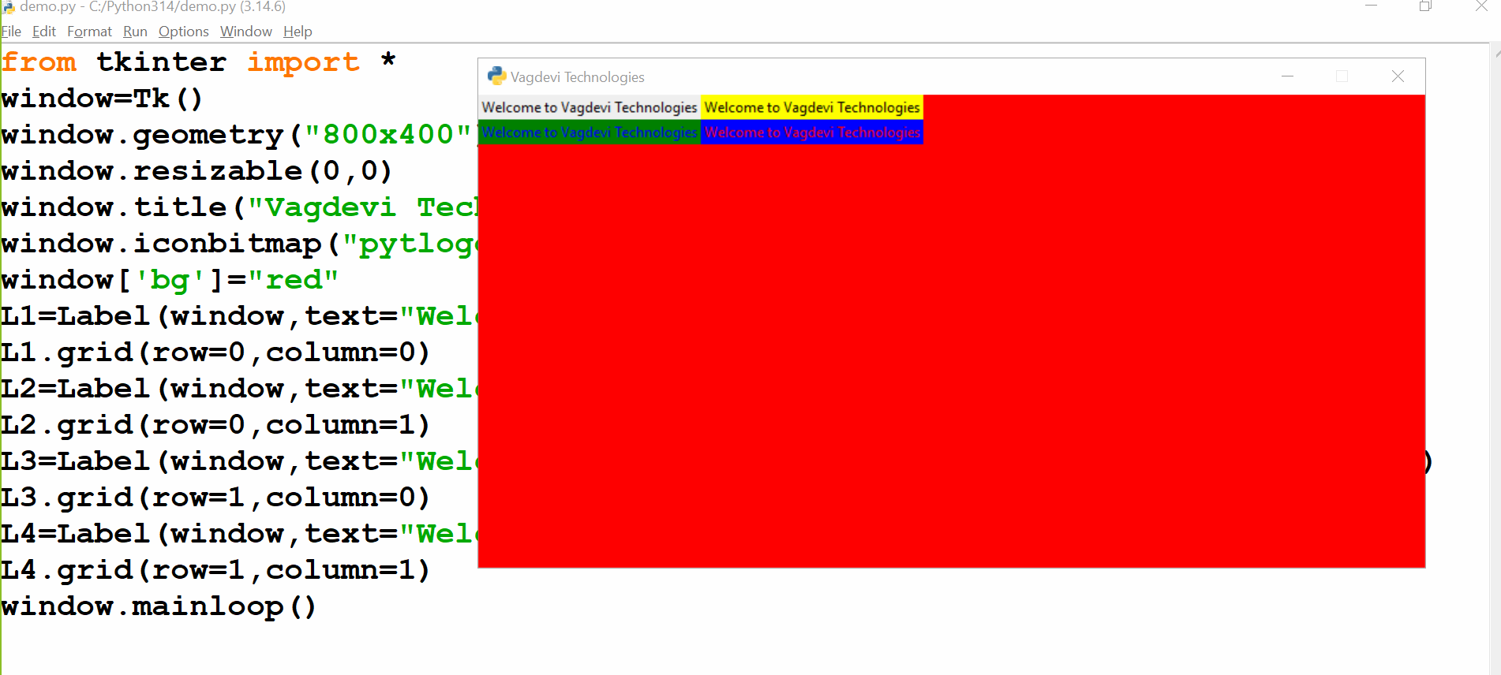
Example11:
demo.py
from tkinter import *
window=Tk()
window.geometry("800x400")
window.resizable(0,0)
window.title("Vagdevi Technologies")
window.iconbitmap("pytlogo.ico")
window['bg']="red"
#varaible decleration
fname=StringVar()
lname=StringVar()

#function decleration
def getfullname():
fn=fname.get()
ln=lname.get()
fullname=fn+" "+ln
L3.configure(text=fullname)

def reset():
fname.set('')
lname.set('')

def close():
window.destroy()

#welcome label
L=Label(window,text="Welcome to Vagdevi Technologies",fg="yellow",bg="red",
font="arial 15 bold")
L.pack(padx=10,pady=20)

#label with entry field
L1=Label(window,text="Enter Your First Name:",bg="red",fg="blue",
font="elephant 15 italic")
L1.place(x=50,y=100)
E1=Entry(window,bd=1,bg="red",fg="yellow",font=("forte",15,"italic"),
textvariable=fname)
E1.place(x=350,y=100)

#label with entry field
L2=Label(window,text="Enter Your Last Name:",bg="red",fg="blue",
font="elephant 15 italic")
L2.place(x=50,y=150)
E2=Entry(window,bd=1,bg="red",fg="yellow",font=("forte",15,"italic"),
textvariable=lname)
E2.place(x=350,y=150)

#buttons(actions)
B1=Button(window,text="GetFullName",bg="yellow",fg="red",font="roman 15 bold",
command=getfullname)
B1.place(x=200,y=200)
B2=Button(window,text="Clear",bg="yellow",fg="red",font="roman 15 bold",
command=reset)
B2.place(x=400,y=200)

B3=Button(window,text="Close",bg="yellow",fg="red",font="roman 15 bold",
command=close)
B3.place(x=550,y=200)

#label for to display full name
L3=Label(window,bg="red",fg="blue",font="verdana 15 bold")
L3.place(x=300,y=250)
window.mainloop()
output
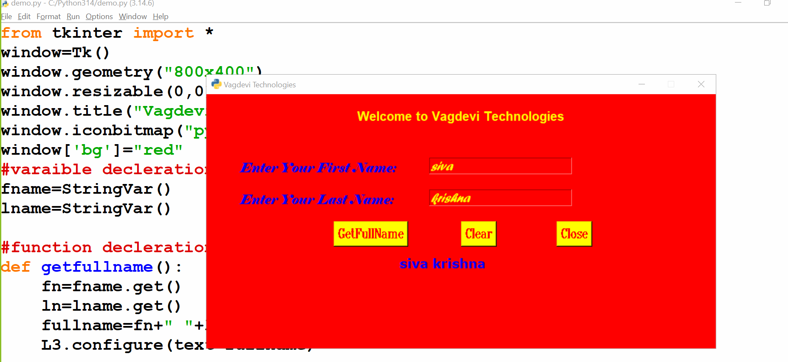
Example12:
demo.py
from tkinter import *
from tkinter import messagebox
window=Tk()
window.geometry("800x400")
window.resizable(0,0)
window.title("Vagdevi Technologies")
window.iconbitmap("pytlogo.ico")
window['bg']="red"
#varaible decleration
fname=StringVar()
lname=StringVar()

#function decleration
def getfullname():
fn=fname.get()
ln=lname.get()
fullname=fn+" "+ln
messagebox.showinfo("Result",fullname)

def reset():
ask=messagebox.askyesno("Confiormation",
"Do You Want to Clear These Fields")
if ask:
fname.set('')
lname.set('')
messagebox.showinfo("Result","Clear the Fields Successfully")
else:
messagebox.showwarning("Result","Dont Clear The Fields")

def close():
ask=messagebox.askokcancel("Confirmation",
"Do You Want to Close the Window")
if ask:
window.destroy()
else:
messagebox.showerror("Result","Don't close the window")

#welcome label
L=Label(window,text="Welcome to Vagdevi Technologies",fg="yellow",bg="red",
font="arial 15 bold")
L.pack(padx=10,pady=20)

#label with entry field
L1=Label(window,text="Enter Your First Name:",bg="red",fg="blue",
font="elephant 15 italic")
L1.place(x=50,y=100)
E1=Entry(window,bd=1,bg="red",fg="yellow",font=("forte",15,"italic"),
textvariable=fname)
E1.place(x=350,y=100)

#label with entry field
L2=Label(window,text="Enter Your Last Name:",bg="red",fg="blue",
font="elephant 15 italic")
L2.place(x=50,y=150)
E2=Entry(window,bd=1,bg="red",fg="yellow",font=("forte",15,"italic"),
textvariable=lname)
E2.place(x=350,y=150)

#buttons(actions)
B1=Button(window,text="GetFullName",bg="yellow",fg="red",font="roman 15 bold",
command=getfullname)
B1.place(x=200,y=200)
B2=Button(window,text="Clear",bg="yellow",fg="red",font="roman 15 bold",
command=reset)
B2.place(x=400,y=200)

B3=Button(window,text="Close",bg="yellow",fg="red",font="roman 15 bold",
command=close)
B3.place(x=550,y=200)

window.mainloop()
output
